**EPT | Endpoint Protection Tools**

**What are endpoint Protection Tools?**

Endpoint security or endpoint protection tools are tools used by many companies from local businesses to enterprises. These tools ensure their day to day operations can run flawlessly without the worry of intrusions. Endpoint devices such as servers, workstations, laptops, smartphones and many other devices are the points where cyber threats intrude a companies’ network. Endpoint protection tools come equipped with firewalls, anti-virus and security software to assure unwanted attempts of access are not made on the endpoints.

Endpoint security tools are a must as more companies are implementing BOYD (Bring your own device). This is where the tools can come in handy to make sure outside threats are not entering via the endpoints.



**How does Endpoint Security Protection work?**

Endpoint protection tools work on a client-server model. The clients network has the security software located on a local server or gateway. The end devices are then connected to the network and are now adopting the security software that make sure their traffic and network usage flows with out any worries of threat or errors.



**Top 10 endpoint protection Tools 2018**

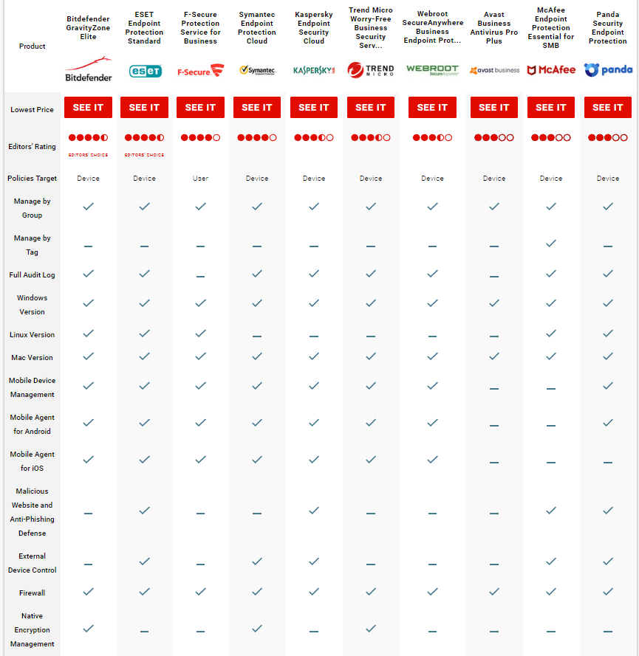

**sources**:

<https://www.pcmag.com/article2/0,2817,2492322,00.asp>

<https://atelier.bnpparibas/en/life-work/article/icts-devices-market-age-pluralism>

<https://www.pcmag.com/article2/0,2817,2492322,00.asp>